 | 7.0.4 Editors - 3D Viewport - Mesh Object - Edit Mode - Face Context Menu
Table of content
Detailed table of content 1
Face Context Menu 6
Subdivide 6
Extrude Faces 7
Extrude Faces Along Normals 8
Extrude Individual 9
Inset Faces 10
Bridge Faces 11
Poke Faces 12
UV Unwrap Faces submenu 13
Smart UV Project 15
Lightmap Pack 16
Triangulate Faces 20
Triangles to Quads 20
Shade Smooth 21
Shade Flat 21
Un-Subdivide 22
Split 22
Separate submenu 22
Dissolve Faces 22
Delete Faces 23
Show/Hide 23

Detailed table of content

Detailed table of content
Detailed table of content 1
Face Context Menu 6
Subdivide 6
Last Operator Subdivide 6
Number of Cuts 6
Smoothness 6
Create N-Gons 6
Quad Corner Type 6
Fractal 7
Along Normal 7
Random Seed 7
Extrude Faces 7
Last Operator Extrude Region and Move 7
Flip Normals 7
Dissolve Orthogonal Edges 7
Move X, Y Z 7
Orientation 7
Mirror Editing 7
Proportional editing 7
Proportional Falloff 7
Proportional Size 8
Connected 8
Projected(2D) 8
Extrude Faces Along Normals 8
Header Value 8
Last Operator Extrude Region and Shrink/Fatten 8
Flip Normals 8
Dissolve Orthogonal Edges 8
Offset 8
Offset Even 8
Mirror Editing 8
Proportional editing 9
Proportional Falloff 9
Proportional Size 9
Connected 9
Projected(2D) 9
Extrude Individual 9
Header Value 9
Last Operator Extrude Individual Faces and Move 9
Offset 9
Offset Even 9
Proportional editing 9
Proportional Falloff 10
Proportional Size 10
Connected 10
Projected(2D) 10
Inset Faces 10
Last Operator Inset Faces 10
Boundary 10
Offset Even 10
Offset Relative 10
Edge Rail 10
Thickness 11
Depth 11
Outset 11
Select Outer 11
Individual 11
Interpolate 11
Bridge Faces 11
Last Operator Bridge Edge loops 11
Connect Loops 11
Merge 11
Merge Factor 11
Twist 11
Number of Cuts 11
Interpolation 12
Smoothness 12
Profile Factor 12
Profile shape 12
Poke Faces 12
Last Operator Poke Faces 12
Poke Offset 12
Offset Relative 12
Poke Center 12
UV Unwrap Faces submenu 13
Unwrap ABF 13
Unwrap Conformal 13
Last Operator Unwrap 13
Method 13
Method Angle based + Conformal 13
Method 13
Fill Holes 13
Use Subdivision Surface 13
Correct Aspect 13
Margin Method 14
Scaled 14
Add 14
Fraction 14
Margin 14
Method Minimum Stretch 14
Iterations 14
No Flip 14
Importance Weight 14
Use Subdivision Surface 14
Correct Aspect 14
Margin Method 14
Scaled 14
Add 14
Fraction 14
Margin 14
Smart UV Project 15
Smart UV Project Settings dialogue 15
Angle Limit 15
Margin Method 15
Scaled 15
Add 15
Fraction 15
Rotation Method 15
Island Margin 15
Area Weight 15
Correct Aspect 15
Last Operator Smart UV Project 15
Lightmap Pack 16
Settings 16
Selection 16
Share Tex Space 16
New UV Map 16
Pack Quality 16
Margin 16
Follow Active Quads 16
Settings 16
Edge Length Mode 16
Last Operator Follow Active Quads 16
Cube Projection 16
Last Operator Cube Projection 17
Cube Size 17
Correct Aspect 17
Clip to Bounds 17
Scale to Bounds 17
Cylinder Projection 17
Last Operator Cylinder Projection 17
Direction 17
Align 17
Pole 17
Preserve Seams 17
Radius 17
Correct Aspect 17
Clip to Bounds 18
Scale to Bounds 18
Sphere Projection 18
Last Operator Sphere Projection 18
Direction 18
Align 18
Pole 18
Preserve Seams 18
Correct Aspect 18
Clip to Bounds 18
Scale to Bounds 18
Project from View 18
Last Operator Project from View 19
Orthographic 19
Camera Bounds 19
Correct Aspect 19
Clip to Bounds 19
Scale to Bounds 19
Project from View (Bounds) 19
Mark Seam 19
Clear Seam 19
Reset 19
Triangulate Faces 20
Last Operator Triangulate Faces 20
Quad Method 20
Shortest diagonal 20
Fixed Alternate 20
Fixed 20
Beauty 20
Polygon Method 20
Clip 20
Beauty 20
Triangles to Quads 20
Last Operator Tris to Quads 20
Max Face Angle 20
Max Shape Angle 20
Topology influence 20
Compare UV's 21
Compare Color attributes 21
Compare Seam 21
Compare Sharp 21
Compare Materials 21
Deselect Joined 21
Shade Smooth 21
Shade Flat 21
Un-Subdivide 22
Last Operator Un-Subdivide 22
Iterations 22
Split 22
Separate submenu 22
Selection 22
By Material 22
By Loose Parts 22
Dissolve Faces 22
Last Operator Dissolve Vertices 22
Dissolve Vertices 22
Delete Faces 23
Show/Hide 23
Show Hidden 23
Hide Selected 23
Last Operator Hide Selected 23
Unselected 23
Hide Unselected 23

Face Context Menu

Call this menu with double right click in the 3D viewport. You need to be in Edit mode with a Mesh object. And in selection mode Edge.
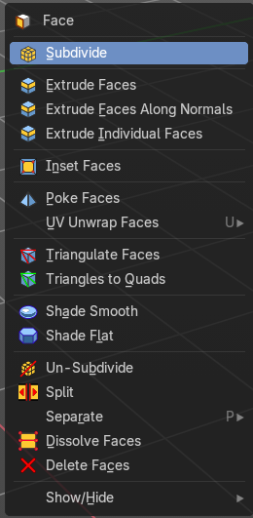
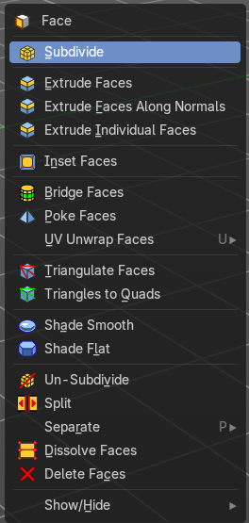
Select geometry to reveal all content.

Subdivide
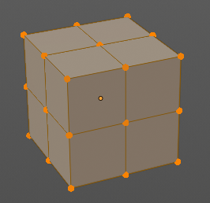
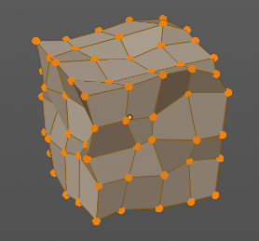
Subdivide divides the selected edges. It subdivides the involved faces too, and can create new vertices.
A more unknown functionality is that it can also randomize the result with the Fractal slider in the Last operator panel.

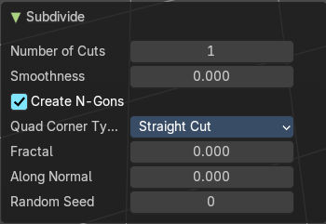
Last Operator Subdivide

Number of Cuts
The number of cuts defines the amount of subdivisions.

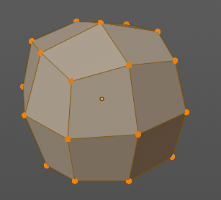
Smoothness
This value defines how smooth the subdivision result is. From flat to bent.

Create N-Gons
Create N-Gons if required. Else subdividing N-Gons creates Tris.

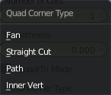
Quad Corner Type
Adjust the corner type.

Fractal
Randomize the selected vertices.

Along Normal
When randomized, this value defines how strong the subdivision follows the normals of the initial vertices.

Random Seed
Randomizing value for fractal randomizing.

Extrude Faces
Extrudes out the selected faces into the face direction by moving the mouse. When it's more than one face, then the middle will be used.

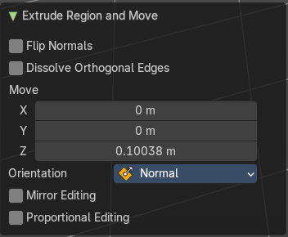
Last Operator Extrude Region and Move

Flip Normals
Flips the normals of the extruded faces.

Dissolve Orthogonal Edges
Dissolves orthogonal edges.

Move X, Y Z
The position. Attention, the actual world orientation and rotation does not matter here. It always starts with a value of zero, and moves relative to this zero then. For the actual location values have a look in the sidebar in the transform panel.

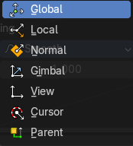
Orientation
The widget can have different orientations. The menu items should be self explaining.

Mirror Editing
Enable mirror editing.

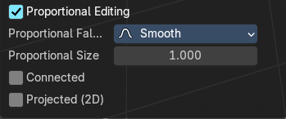
Proportional editing
Enables proportional editing. Activating proportional editing reveals further settings.

Proportional Falloff
Adjust the falloff methods.

Proportional Size
See and adjust the falloff radius.

Connected
The proportional falloff gets calculated for connected parts only.

Projected(2D)
The proportional falloff gets calculated in the screen space. Depth doesn't play a role. When it's in the radius, then it gets calculated.

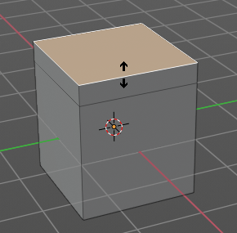
Extrude Faces Along Normals
Extrudes the selection along local normals.

Header Value
This tool works like a shrink fatten extrude. And so you will see a corresponding set of values in the header.

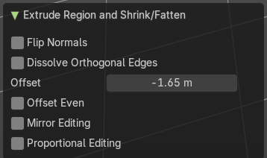
Last Operator Extrude Region and Shrink/Fatten

Flip Normals
Flips the normals of the extruded faces.

Dissolve Orthogonal Edges
Dissolves orthogonal edges.

Offset
The current extrude amount.

Offset Even
Scales the offset to give more even thickness. Without this checked the farer away faces will have a bigger extrude amount.

Mirror Editing
Enable mirror editing.

Proportional editing
Enables proportional editing. Activating proportional editing reveals further settings.

Proportional Falloff
Adjust the falloff methods.

Proportional Size
See and adjust the falloff radius.

Connected
The proportional falloff gets calculated for connected parts only.

Projected(2D)
The proportional falloff gets calculated in the screen space. Depth doesn't play a role. When it's in the radius, then it gets calculated.

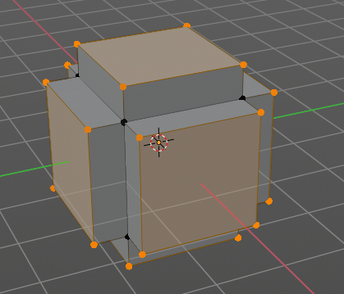
Extrude Individual
Extrudes the selection along local normals of each individual face.
The method works the same in all Mesh select modes. Vertice, Edge and Face Mode.

Header Value
This tool works like a shrink fatten extrude. And so you will see a corresponding set of values in the header.

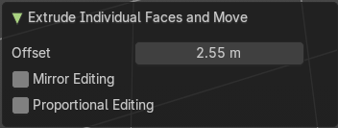
Last Operator Extrude Individual Faces and Move

Offset
The current extrude amount.

Offset Even
Scales the offset to give more even thickness. Without this checked the farer away faces will have a bigger extrude amount.

Proportional editing
Enables proportional editing. Activating proportional editing reveals further settings.

Proportional Falloff
Adjust the falloff methods.

Proportional Size
See and adjust the falloff radius.

Connected
The proportional falloff gets calculated for connected parts only.

Projected(2D)
The proportional falloff gets calculated in the screen space. Depth doesn't play a role. When it's in the radius, then it gets calculated.

Inset Faces
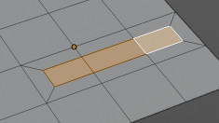
Inset insets edges into the selected faces. Think of it as an extrude inwards the face.
Activate the tool, drag the mouse. But carefully. The control is not the best. You better adjust the amount in the last operator.

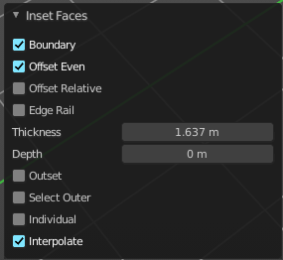
Last Operator Inset Faces

Boundary
With Boundary ticked you will get the connect edges in the corners. Without the edges ends straight.
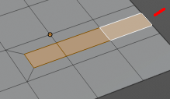

Offset Even
Scales the offset to give more even thickness.

Offset Relative
Scales the offset by surrounding geometry.

Edge Rail
Inset the region along existing edges.

Thickness
Thickness adjusts the thickness of the inset geometry.

Depth
With depth you can bevel the inset geometry. It is then not longer co planar to the initial face.

Outset
With outset ticked the Inset will not extrude inwards but outwards.

Select Outer
With Select Outer the outer ring will be selected after the Inset.

Individual
Inset every face individually.

Interpolate
Blend Face Data across the inset.

Bridge Faces
The Bridge Faces tool bridges selected faces, and adds polygons between them. You need to have at least two faces selected.
This tool is basically the Bridge Edge Loops tool, just that it operates in Face mode.
Note that this tool just shows when you are in Face Select Mode.

Last Operator Bridge Edge loops

Connect Loops
Choose the method how to deal with bridging multiple loops.

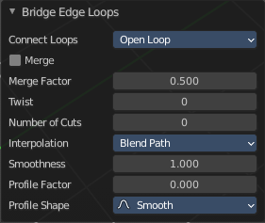
Merge
With merge ticked it will not create a bridge face, but merge the selected edges.

Merge Factor
The merge factor determines at which distance between the selected edges the merge happens. 0.5 is the middle of the selected edges.

Twist
The twist offset for closed loops.

Number of Cuts
Adds cuts to the bridge face.

Interpolation
Choose the interpolation mode for the cuts.

Smoothness
Adjust the smoothness for the cuts.

Profile Factor
Adjust the profile factor for the cuts.

Profile shape
Adjust the profile shape for the cuts.

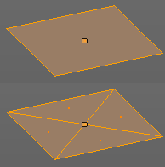
Poke Faces
Splits the selected faces to create a triangulated geometry.

Last Operator Poke Faces

Poke Offset
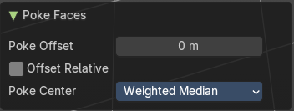
Normally the center vertice of the poke operation is planar with the rest. Adjust an offset.

Offset Relative
Scale the offset by surrounding geometry.
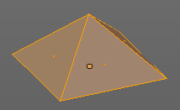

Poke Center
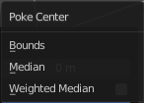
Poke Center is a drop-down box choose what the center of the poke operation should be. You can choose between weighted mean, mean and bounds.

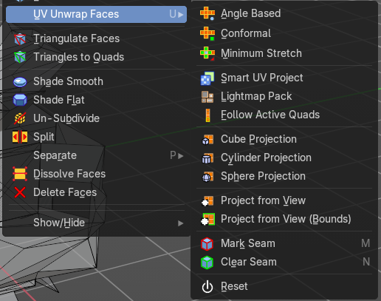
UV Unwrap Faces submenu
The UV menu from the header.
Here you find the UV mapping methods and some further functionality. You use it best in the U Editing layout. There you can see the result in the UV Editor then.
The UV menu is just available for Mesh objects

Unwrap ABF
Unwrap ABF unwraps the selected geometry with the method Angle based. ABF stands for Angle Based Flattening. ABF can give a bit better result than LSCM when unwrapping organic shapes.

Unwrap Conformal
Unwrap Conformal unwraps the selected geometry with the method LSCM, which is the short for Least Square Conformal Mapping. LSCM can give a bit better results than ABF with geometric shapes.

Last Operator Unwrap

Method
Method is a drop down box where you can choose the unwrap method.

Method Angle based + Conformal
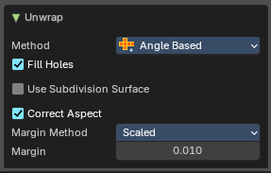
Unwrap ABF and Unwrap LSCM shares the same Last Operator.

Method
Method is a drop down box where you can choose between Unwrap method Angle Based and Conformal.

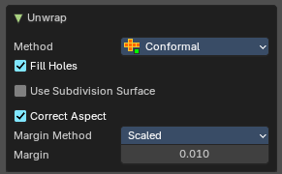
Fill Holes
Fill holes in the mesh before unwrapping.

Use Subdivision Surface
Unwraps an existing Subdivision Modifier. You need to add a Subdivision Modifier first.

Correct Aspect
Take the Image Aspect Ratio into account.

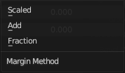
Margin Method

Scaled
Use the scale of existing UV to multiply margin.

Add
Just add the margin and ignore any existing UV.

Fraction
Specify a precise fraction of specific UV.

Margin
The distance between the single UV patches.

Method Minimum Stretch
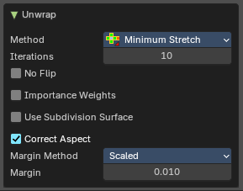

Iterations
Number of iterations.

No Flip
Prevent flipping UV's

Importance Weight
Take per vertex importance weights into account.

Use Subdivision Surface
Unwraps an existing Subdivision Modifier. You need to add a Subdivision Modifier first.

Correct Aspect
Take the Image Aspect Ratio into account.

Margin Method

Scaled
Use the scale of existing UV to multiply margin.

Add
Just add the margin and ignore any existing UV.

Fraction
Specify a precise fraction of specific UV.

Margin
The distance between the single UV patches.

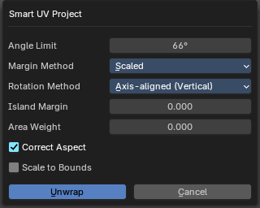
Smart UV Project
Smart UV Project projects the UV mapping from different angles.

Smart UV Project Settings dialogue

Angle Limit
The Angle Limit defines after which angle the mapping happens from the next side. With an angle of 66 you have around six sides to map from. The calculation is 360/66.

Margin Method

Scaled
Use the scale of existing UV to multiply margin.

Add
Just add the margin and ignore any existing UV.

Fraction
Specify a precise fraction of specific UV.

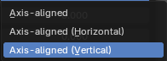
Rotation Method
How to rotate islands.

Island Margin
Island Margin defines the distance between the UV patches.

Area Weight
Weight Projection Vector by faces with larger areas.

Correct Aspect
Take the Image Aspect Ratio into account.

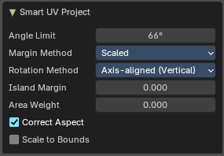
Last Operator Smart UV Project
The Last Operator for Smart UV Project contains the same settings than the Smart UV Project Settings dialogue.

Lightmap Pack
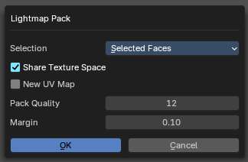
Lightmap Pack maps each face individually, and puts the result into the UV space. Without margin.
Lightmap Pack has no Last Operator.

Settings

Selection
Selection is a drop-down box where you can choose what will be packed, either Selected Faces or All Faces.

Share Tex Space
Map all objects into one lightmap.

New UV Map
Create a new UV map for every new mesh.

Pack Quality
The pack quality.

Margin
The distance between the single UV patches.

Follow Active Quads
Follow Active quads maps UV coordinates starting from an active face, and maps all adjacent faces in quad shape then. This way you can for example unwrap a pipe or a road. You first need to have a face selected. Then select everything. And then click at Follow Active Quads.

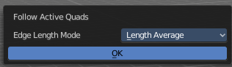
Settings

Edge Length Mode
Edge Length Mode is a drop-down box where you can choose the Length method.

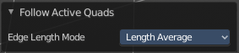
Last Operator Follow Active Quads
The Last Operator contains the same settings than the Settings dialogue.

Cube Projection
Cube Projection maps the mesh from six sides, means cubic.

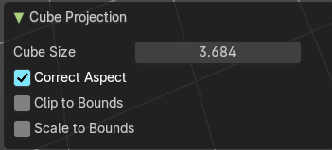
Last Operator Cube Projection

Cube Size
Cube Size defines the size of the UV mesh in the UV space.

Correct Aspect
Take Image Aspect ratio into account.

Clip to Bounds
Clip UV Coordinates to bounds after unwrapping.

Scale to Bounds
Scale UV Coordinates to bounds after unwrapping.

Cylinder Projection
Cylinder Projection tries to map the geometry cylindric.

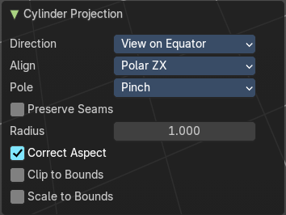
Last Operator Cylinder Projection

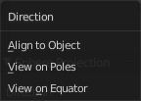
Direction
Direction is a drop-down box where you can choose in which direction the spherical projection will be mapped.

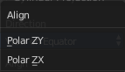
Align
Align is a drop-down box where you can choose the Align method.

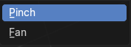
Pole
How to handle the faces at the poles.

Preserve Seams
Keep existing seams intact.

Radius
Radius defines the Polar size of the UV mesh in the UV space.

Correct Aspect
Take Image Aspect ratio into account.

Clip to Bounds
Clip UV Coordinates to bounds after unwrapping.

Scale to Bounds
Scale UV Coordinates to bounds after unwrapping.

Sphere Projection
Sphere Projection tries to map the geometry spherical.

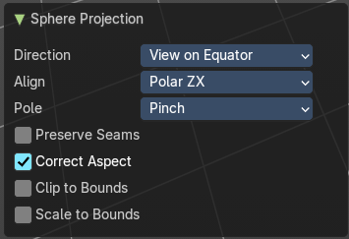
Last Operator Sphere Projection

Direction
Direction is a drop-down box where you can choose in which direction the spherical projection will be mapped.

Align
Align is a drop-down box where you can choose the Align method.

Pole
How to handle the faces at the poles.

Preserve Seams
Keep existing seams intact.

Correct Aspect
Take Image Aspect ratio into account.

Clip to Bounds
Clip UV Coordinates to bounds after unwrapping.

Scale to Bounds
Scale UV Coordinates to bounds after unwrapping.

Project from View
Project from View projects the UV from the current 3D view.

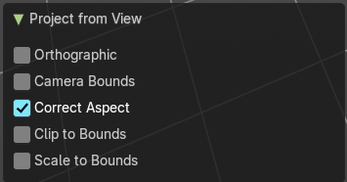
Last Operator Project from View

Orthographic
User orthographic projection.

Camera Bounds
Map UV's to the camera region taking resolution and aspect into account.

Correct Aspect
Take Image Aspect ratio into account.

Clip to Bounds
Clip UV Coordinates to bounds after unwrapping.

Scale to Bounds
Scale UV Coordinates to bounds after unwrapping.

Project from View (Bounds)
Project from View projects the UV from the current 3D view.
Same as Project from View, but with Scale to Bounds ticked in the Last operator. And so it scales to the bounds.

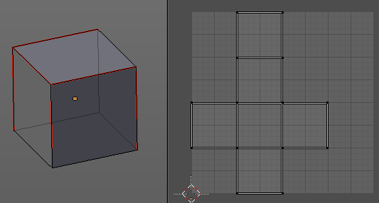
Mark Seam
The unwrap algorithms Angle based and Conformal requires to have edges marked as seams. Think of it as a cutting pattern for a trouser for example. Such a trouser is also made of fabric patterns.
Same goes for the UV patches when you use Angle based or conformal unwrapping. You need to cut your mesh into parts and mark edges as seams, so that the algorithm knows where the seams are.
Mark seam marks the currently selected edge(s) as a seam. Seam edges will be displayed as red in the 3D viewport.

Clear Seam
Clear seam removes the seam from the currently selected edge(s).

Reset
Resets the UV Projection.

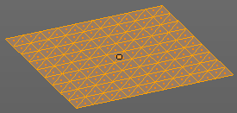
Triangulate Faces
Triangulate Faces triangulates the faces of the selected geometry.

Last Operator Triangulate Faces

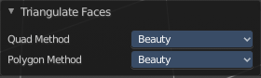
Quad Method
Choose how quads should be triangulated.

Shortest diagonal
Splits the quads based on their distance between vertices.

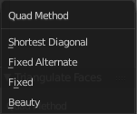
Fixed Alternate
Splits the quads on the second and fourth vertice.

Fixed
Splits the quads on the first and third vertice.

Beauty
Tries to optimize the triangulation.

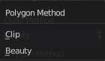
Polygon Method
Choose how N-Gons should be triangulated.

Clip
Splits the polygons with an ear clipping algorithm.

Beauty
Tries to optimize the triangulation.

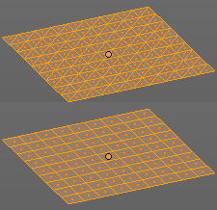
Triangles to Quads
Tris to quads tries to convert triangulated geometry back to a quad geometry by removing the edges inside of the quads.

Last Operator Tris to Quads

Max Face Angle
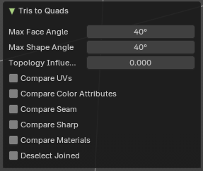
Adjust the threshold to adjacent triangles.

Max Shape Angle
Adjust the shape angle limit.

Topology influence
How much to priorize regular grids of qads as well as quads that touch existing quads.

Compare UV's
Takes the UV patches for the calculation into account. Border geometry will not be calculated.

Compare Color attributes
Takes the Vertex colors for the calculation into account. Border geometry will not be calculated.

Compare Seam
Takes the Vertex colors for the calculation into account. Border geometry will not be calculated.

Compare Sharp
Takes the as sharp marked edges for the calculation into account. Border geometry will not be calculated.

Compare Materials
Takes the Materials colors for the calculation into account. Border geometry will not be calculated.

Deselect Joined
Only select remaining triangles that were not merged.

Shade Smooth
Sets the shading for the object to smooth. Flat means that every face of the object shows facettet, with a sharp edge. Smooth means that the edges are not longer to see.
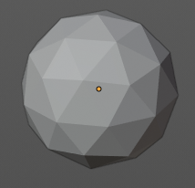
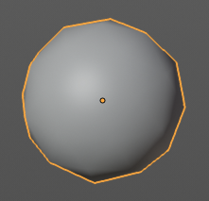

Shade Flat
Sets the shading for the object to flat. Flat means that every face of the object shows facettet, with a sharp edge. Smooth means that the edges are not longer to see.

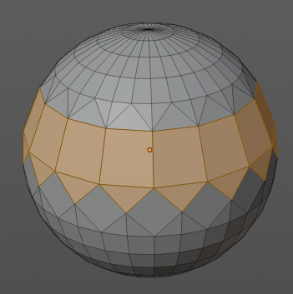
Un-Subdivide
Decimates the geometry by trying to make one quad out of four quads. But can also end in Tris where this is not possible.

Last Operator Un-Subdivide

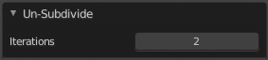
Iterations
Number of iterations. This means how deep the calculation should go. One level of SDS, two levels, three levels, etc. . Down to the point where you cannot decimate any geometry anymore.

Split
Splits the edges between the selected vertices. It creates two edges out of one. And splits the edge by that.

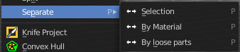
Separate submenu
Separate separates the selected geometry, and creates a new object. The geometry becomes uneditable, since it is now a new object. You will have to leave the Edit mode, select the new object, and re-enter Edit mode when you want to edit it.

Selection
Selection separates the current selection.

By Material
By Material separates all geometry that has the same material than the current selection.

By Loose Parts
By Loose parts separates all geometry that is connected by edges to the current selection.

Dissolve Faces
Dissolves the selected faces, which unions the involved faces to one.

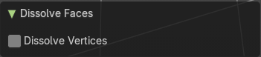
Last Operator Dissolve Vertices

Dissolve Vertices
Dissolve remaining vertices.

Delete Faces
Deletes the selected faces.

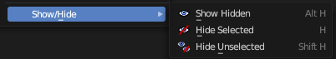
Show/Hide
Sub-menu with shows or hide selection, unselected or hidden operators.

Show Hidden
Makes all geometry in the scene visible again.

Hide Selected
Hides the selected geometry.

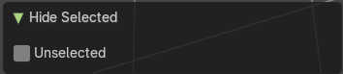
Last Operator Hide Selected

Unselected
Hides the not selected geometry.

Hide Unselected
Hides the not selected geometry. The selected geometry stays visible.

